4/25/2020

Alexander Dao

Cosc 412

EduCycle Website

Software Project Management Plan



**Update History**

|  |  |  |  |
| --- | --- | --- | --- |
| **Version #** | **Revision**  **Date** | **Approved By** | **Reason** |
| 1.0 | 02/18/2020 | Julie Leary/Alexander Dao | Create Schedule, Use cases, Requirements, Create SPMP  Went over website ideas and goals with supervisor. |
| 1.1 | 02/28/2020 | Julie Leary/Alexander Dao | Domain bought; creation of website began.  Look into themes and plugins. Forms (3) completed. |
| 1.2 | 03/02/2020 | Julie Leary/Alexander Dao | Create Calendar and connect it with EduCycle’s email for Reconditioning schedules |
| 1.3 | 03/09/2020 | Julie Leary/Alexander Dao | Upload the word search game onto the website. Also implemented the login, register, member, users, and account pages. |
| 1.4 | 3/25/2020 | Julie Leary/Alexander Dao | Organized Website, Explanation of program, subscribe for newsletter section, Added TU and EduCycle Logo. |
| 1.5 | 4/01/2020 | Julie Leary/Alexander Dao | Reorganized website and page test. |
| 1.6 | 4/03/2020 | Julie Leary/Alexander Dao | Created a Q&A section  Created a “About us” page with current staff  Created page of computer/hardware EduCycle has |
| 1.6 | 4/09/2020 | Julie Leary/Alexander Dao | Database Created to connect types of hardware to the website  Allow different log-in information for student employees  Forms to request a computer is sent to the EduCycle Email |
| 1.7 | 4/15/2020 | Julie Leary/Alexander Dao | Check to see if system can be on mobile and tablets  Went over website and goals with supervisor |

**Preface: Scope and Purpose**

From 2014, EduCycle has taken out of lifecycle computers from Towson University and reconditioned them for reuse. This has lessened the technology trash on campus as well as saved thousands of dollars of students’ money. Reconditioning sessions have gone far to not only involve TU students, but also Baltimore Public Schools in the general area.

Base on this, the development of a website geared to non-TU schools will be created. This will create an easy way for schools, K-12, to learn more about the EduCycle Program, be involved in our reconditioning sessions, receive recondition computers (at no charge), and a faster way to reach one of the managers in charge for further assistance. This website will consist of informative pages that will give the user more knowledge about the entire program as a whole, as well as learning more to take part.

**Table of Contents**

1. Introduction…………………………………………………………………………………… 5  
 1.1 Project Overview …………………………………………………………………. 5  
 1.2 Project Deliverables …………………………………………………………….... 5  
 1.3 Evolution of the SPMP …………………………………………………………... 5  
 1.4 Reference Materials …………………………………………………………….... 5  
 1.5 Definitions and Acronyms………………………………………………………... 6

2. Project Organization……………………………………………………………………...  
 2.1 Process Model …………………………………………………………………..  
 2.2 Organizational Structure ………………………………………………………..  
 2.3 Organizational Interfaces ……………………………………………………….  
 2.4 Project Responsibilities …………………………………………………………

3. Managerial Process ……………………………………………………………………….  
 3.1 Management Objective and Priorities …………………………………………..  
 3.2 Assumptions, Dependencies, and Constraints ………………………………….  
 3.3 Risk Management ………………………………………………………………  
 3.4 Staffing Plan …………………………………………………………………....  
 3.5 Monitoring and Controlling Mechanisms ……………………………………...

# **Part I: Introduction**

## 1.1 Project Overview

Develop a website that allows Baltimore County Schools staff to apply for Reconditioning sessions and receive donated computers, monitors, and A/V components. The website will provide the user with pages that offer each of the categories above. This site will possibility help create a better environment for schools to learn more about the program and create an easier way for TU’s OTS to manage and promote their program.

1.2 Project Deliverables

Create an website that incorporates:

1. Forms for client to fill out
   1. Volunteering to help recondition computers
   2. Apply for a reconditioning session (Non-TU use)
   3. Request for technology (Non-TU use)
2. An overview of the program as a whole
   1. What program has to offer with reconditioning computers
   2. The purpose of reconditioning sessions
   3. How could Baltimore County Schools could benefit from the program

We will add to the timeline as changes arise. We anticipate there will be several changes to our project as we go along. We will be sure to work on the project in advance prior to due dates to prepare for any unanticipated changes.

1.3 Reference Materials

Towson University originally has a website that explains the functionality of the program for Towson’s Facility and staff.

https://www.towson.edu/technology/facultystaff/hardwaresoftware/buying/reconditioning.html?utm_source=redirect&utm_content=educcycle

1.4 Definitions and Acronyms

EduCycle: Name of program, hosted by Towson University

OTS: Office of Technology Services

TU: Towson University

Recondition: Restoring to good condition (by replacing parts)

SPMP: Software Project Management Plan

# **Part II: Project Organization**

## 2.1 Process Model

Users will be able to create an account on the website. Users can have their processes saved and can pick up where they left off on their game.

## 2.2 Organizational Structure

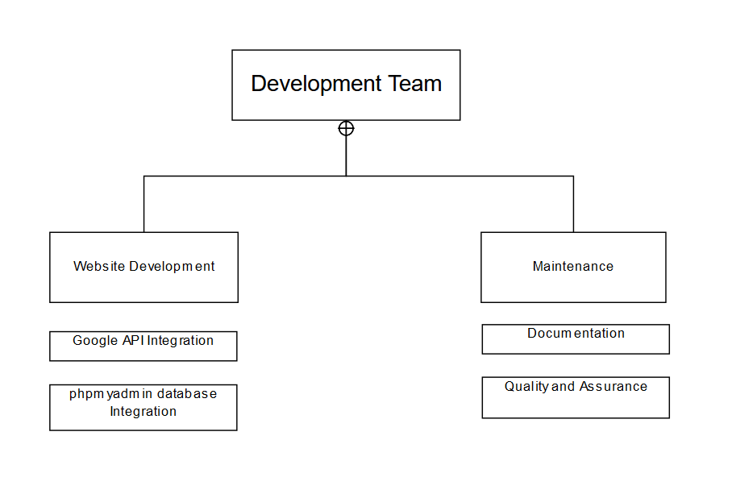

## 

## 2.3 Organizational Interface

Visual Paradigm Online (<https://online.visual-paradigm.com/>) software used to create organizational structure and WBS.

## 2.4 Project Responsibilities

|  |  |  |
| --- | --- | --- |
| Role | Description | Person |
| Project Manager | * Find new tasks to add to agenda | ALEXANDER DAO |
| Planning Manager | * Organize schedule for project * Declare deadlines for tasks to be completed | ALEXANDER DAO |
| Website Development Manager | * Research and implement website features | ALEXANDER DAO |
| QA/Process Manager | * Create quality assurance plan * Write down quality problems * Establish quality development standards * Act as inspector and recorder of project specifications | ALEXANDER DAO |
| Documentation Lead | * Monitor and record all resources used * Record budget of the product | ALEXANDER DAO |

# **Part III: Management Process**

The management of the software project includes four focus areas. The first area is where we define our objectives and priorities. The second area focuses on the assumptions, dependencies, and constraints of the project itself. The third area will focus on the risk management of the process. Lastly, the final area will focus on monitoring and controlling for reporting.

## 3.1 The Management Objectives

The project schedule below presents a listing of tasks, activities, and deliverables associated with the planning and requirements gathering stages for this project. In developing this software, it is difficult to have detailed tasks and activities at this stage of development. As of 2/24, out current schedule is laid out as follows:

|  |  |  |
| --- | --- | --- |
| Phase | Project Deliverables | Due |
| Initial Structuring | * Brainstorm ideas for website * Create schedule | 2/30/2020 |
|  | * Create Use Case * Continue filling out SPMP * Fill-out Requirements   + Work with Julie Leary to see requirements needed for her | 3/25/2020 –  Meeting with Broadwater (Design Review Mtg) |
| Paste 1- Software Development | * Make edits from the meeting with Broadwater * Look into cost for websites and plug-ins * Begin creating website * Understand what the core functionalities are that are necessary. * Go over Requirements #1-6   + Get the three forms created and implemented |  |
| Phase 1- Testing | * Testing the website for possible bugs * Check the following:   + Surveys can be filled out   + Survey is loaded up to a database and stored   + All links load   + Videos are clickable and viewable * Make sure the website complies with all of the guidelines/requirements covered | 4/1/2020 -Personal Deadline |
| Phase 2- Software Development | * Update coding for bugs found in Testing * Go over Requirements 7-15 * Update SPMP,Gantt Chart * Update with Julie Leary with website | 4/10/2020 |
| Paste 2- Testing | * Testing the website for possible bugs * Check the following:   + Data from the database can be loaded and seen on the website   + Check all pages on different web browsers, phones, tablets   + Calendar   + Videos are clickable and viewable * Make sure the website complies with all of the guidelines/requirements covered | 4/15/2020 -Meeting with Broadwater |
| Phase 3 Final | * Make final edits to website * Final Software Project Management Plan * Prototype Presentation | 5/1/2020 |

NOTE: There should be continued documentation throughout each phase. Continue to update the SPMP and fill out any required paperwork needed

## 3.2 Assumptions, Dependencies, and constraints

**Assumptions:**

* Being able to work together with EduCycle’s Coordinator, Julie Leary, on a weekly basis (at least bi monthly)
* All programs and edits to the website will work properly

**Dependencies:**

* User interface for website must be user friendly and visibly pleasing to the client’s specifications (Julie Leary’s)

**Constraints:**

* Acquiring data during coronavirus pandemic
* Meeting with Supervisor on a weekly basis (due to busy schedule of both parties)
* Final Project due 5/1/2020
* Cost- $8.99/year

## 3.3 Risk Management

Will have a meeting with Julie Leary every Tuesday at 3pm to discuss about the website

Routinely update client on the status of the project, assure that all requirements are met and website is coming along smoothly

Understanding possible risk that can occur and create contingency plans for those risks.

## 3.4 Monitoring and Controlling for Reporting

GitHub, storing a separate folder on desktop for back-up.

# **Part IV: Technical Process**

## 4.1 Methods, Tools and Techniques

Methods:

* An Agile model was used to best accommodate for the changes in requirements so the design can be updated accordingly.

Tools:

* Wordpress.org
* Agile
* Host(namecheap.com)
* Elementor
* Updraftplus
* wpDataTable

Techniques:

* Used Wordpress/HTML/CSS to develop the website

## 4.2 Software Documentation

All of the updated documentation will be located on page 2. This will have a detailed description of what was changed and the date that it was completed.

## 4.3 Project Support Functions

Plans for the project’s support functions. The website will need all of the following in order to create a fun and interactive game for youth that educates them about healthy lifestyle decisions.

**Quality Assurance:**

* Update history
* Weekly reviews with supervisor
* Constant review of website to ensure website is functional
* Verify each plugin is up-to-date and will not crash the website
* Screen for bugs in the system before deployment
* Ensure database is up-to-date and viewable on the user end
* Deploy a test to evaluate the user experience and record any issues that may occur
* Correct any errors or bugs that may occur during testing

**Configuration Management Plan:**

* Verify each plugin is up-to-date and will not crash the website
* Screen for bugs in the system before deployment

**Verification and Validation Plan:**

* Test website every other day and check if all plugins are up-to-date
* Make sure all plugins work after every update

## 

# **Part V: Description of Work Packages**

## 5.1 Work Breakdown Structure (WBS)

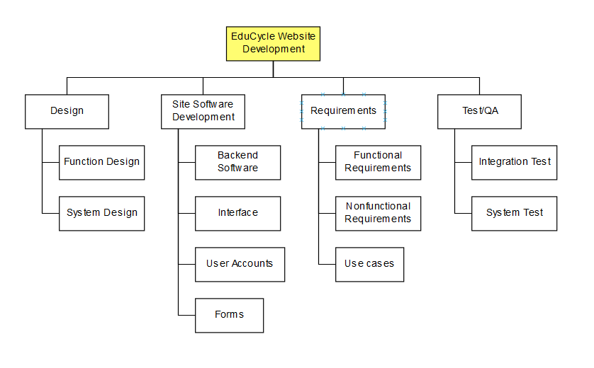

## 5.2 Gannt Chart